PAUWELS TRAVEL BUREAU LTD
Mailing Address: 43 Condor Street, Kitchener, Ontario, N2K 0B2, Canada
519-753-2695 | tours@pauwelstravel.com
www.pauwelstravel.com | Ont. Reg. #1034992

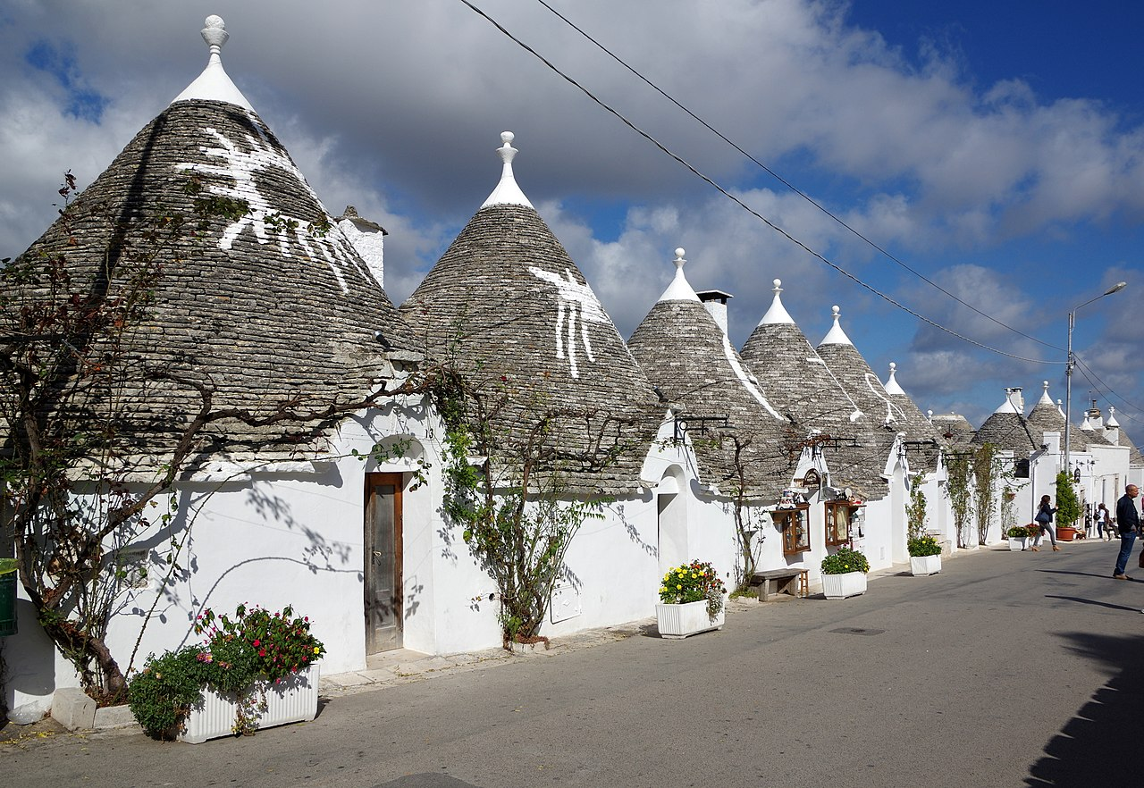
“Trulli” near the town of Alberobello, A UNESCO World Heritage Site

THE OTHER ITALY:
A TOUR OF ITALY’S SOUTHERN PROVINCE OF PUGLIA

15 days, from Monday, November 24 to Monday, December 8, 2025

A leisurely exploration of the little-known but scenic and fascinating “heel” of the Italian “boot,” the province of Puglia (a.k.a. Apulia), offering fabulous coastal and mountain scenery, plus Ancient Greek as well as Roman, Medieval, and Baroque historical towns, sites and monuments! Featuring 4-star/first-class hotels and excellent food, this tour will be escorted by historian Jacques R. Pauwels, PhD, who will lecture on the history of Puglia, the Ancient Greeks and Romans, and Italy in general.

Tour Price: $5,995 CAD
Includes return airfare from Toronto to Rome
Land only: $4,595 CAD
Single Supplement: $885

PROPOSED ITINERARY

Day 1 – Monday, November 24: Departure at 7:30 PM on Air Canada’s non-stop flight from Toronto to Rome.
Day 2 – Tuesday, November 25: Arrival in Rome at 10 AM. A comfortable private coach will be waiting to take us along the trajectory of the legendary Appian Way (a Roman road connecting Rome to Puglia, recently declared a UNESCO World Heritage Site) to visit Monte Cassino, where a terrible battle was fought in WW II, and then to the town of Benevento in the province of Campania. Accommodation in the centrally located four-star Hotel Antum and dinner in the hotel or in a nearby restaurant.
Day 3 – Wednesday, November 26: After a look at Benevento’s main attractions” first, Italy’s finest triumphal arch, named after Emperor Trajan; and second, the 8th-century Santa Sofia Church, a UNESCO World Heritage Site. Then we motor to Matera, the picturesque little capital of the mountainous province of Basilicata, whose name conjures up the title of the Byzantine governors of southern Italy, basilos. The main attractions here are the Sassi, “pebbles,” a troglodyte settlement of houses, some of them already inhabited in the Stone Age, and no less than 130 ancient Byzantine churches, a complex also ranked as a UNESCO World Heritage Site. On into the province of Puglia (or Apulia), the “heel” of the Italian “boot,” for overnight in the four-star Hotel del Sole in the historical centre of the seaport of Taranto. Dinner in a nearby restaurant.
Day 4 – Thursday, November 27: Taranto, one of the most important Greek seaports in southern Italy since the time when the ancient Greeks settled here, in the land they called Megalè Hellas (Latin: Magna Graecia), “Greater Greece.” The quaint old town occupies a peninsula tucked between a bay of the Gulf of Taranto, called Mar Grande, “Big Sea,” and a lagoon called Mar Piccola, “Little Sea.” Highlights will be the palm tree-lined waterfront promenade, the Aragonese Castle, the Duomo (Cathedral), and the remains of a Greek temple. No group dinner this evening.
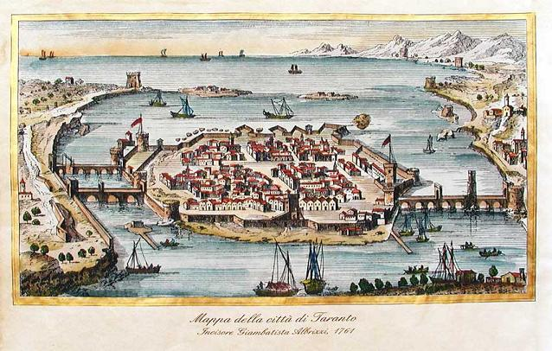
Taranto on a 16th-century painting >
Day 5 – Friday, November 28: Excursion to the region of the “Trullli,” curious dwellings with conical roofs, a UNESCO World Heritage Site. in and around the town of Alberobello and the picturesque neighbouring town of Locorotondo. On the way back to Taranto, we may have time to visit the pretty hilltop town of Ostuni and/or a winery. Today, group lunch or dinner.
Day 6 – Saturday, November 29: This morning we take a sidetrip to a quaint village, Massafra, famous for its churches carved out of the rock. In the afternoon, visit to Taranto’s National Archaeological Museum, featuring countless mementoes of the Hellenic past of this city and region, including beautiful statues and vases. Rest of the day free to shop or explore on your own. No group dinner.
Day 7 – Sunday, November 30: Departure from Taranto after breakfast. We explore the tip of the “heel” of Italy, an isolated and rugged but scenic Puglian peninsula tucked between the Adriatic and the Ionian Seas, known as the Salento. Via Manduria, a walled town dating back to the 8th century BC, famous for its Primitivo, Puglia’s highly rated, internationally famous red wine, we head for Gallipoli, a quaint little seaport on an offshore island. In the afternoon, we continue to Otranto, the most oriental of all Italian cities, overlooking the Strait of Otranto, that is, the narrow stretch of water between the Adriatic and the Ionian Seas, facing Albania. Turning inland, we reach the city of Lecce, the capital city of Salento, where we check into the traditional first-class Grand Hotel. Dinner in the hotel or in a nearby restaurant.
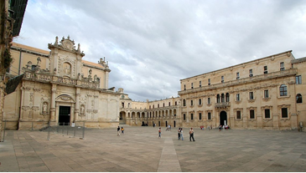
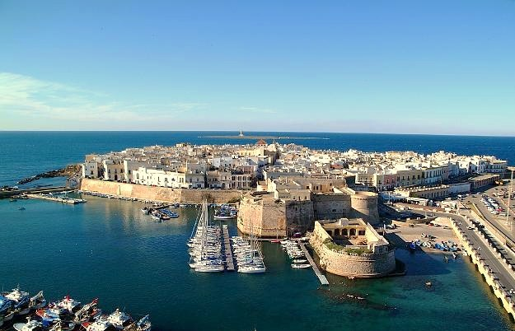
Day 8 – Monday, December 1: After a leisurely breakfast, sightseeing by little tourist train of Lecce, a city famous for its baroque churches and palaces dating back to its “golden age,” lasting from the 16th to the 18th centuries. Among the highlights will be the Roman Theatre, the Piazza del Duomo (Cathedral Square), and the Sant Croce Basilica. The afternoon is free to shop, visit one of more of the local museums, and/or explore picturesque Lecce on your own. No group dinner this evening.
Gallipoli and Lecce’s Piazza del Duomo

Day 9 – Tuesday, December 2: Departure from Lecce after breakfast. We head for the historic Adriatic seaport of Brindisi, in Antiquity the terminus of the famous Appian Way, still marked today by two Roman columns. On to the hilltop town of Ostuni, an architectural jewel commonly referred to as “the White Town” for its mostly white-painted architecture, where we pause for lunch. In the afternoon we continue to Bari, Puglia’s biggest city and a busy Adriatic seaport connecting Italy to Greece. Dinner and overnight in the centrally located 4-star/first-class Hotel Excelsior Bari.
Day 10 – Wednesday, December 3: Morning sightseeing tour of Bari, with as highlights the impressive Romanesque Basilica dedicated to the immensely popular Saint Nicholas with his Turkish-Greek connection (to be explained by your tour guide), the Cathedral, the castle built by German Emperor Frederick II, and the rest of the attractive, labyrinthine old town (Bari Vecchia) as well as the monumental waterfront. Afternoon free to shop, explore the city on your own, and/or visit museums like the Archaeological Museum and the Pinacoteca, featuring Byzantine icons as well as paintings by Italian masters such as Tintoretto, Bellini, Veronese, and De Chirico. No group dinner this evening.

“In Puglia, everything the Italophile craves is here in abundance: ancient towns, extravagant churches, seas of olives, olive-green seas and food to equal of anywhere else in Italy” (Lonely Planet)
For a video on the highlights of Puglia, see here.

Day 11 – Thursday, December 4: We leave Bari and head inland for a visit to Castel del Monte, a mighty medieval castle in a lonely but scenic setting, built by Emperor Frederick II and a unique blend of Cistercian and other occidental as well as oriental, i.e., Byzantine and Islamic, architecture. On into the area that witnessed the 216 BC Battle of Cannae, Hannibal’s most famous victory against the Romans, and to the town of Barletta, a seaport on the Adriatic. A must-see here is the “Colossus,” a huge bronze 4th-century statue of a Roman emperor. In the afternoon we continue along the coast to the mountainous and forested Gargano Peninsula, the “spur” of the Italian boot, one of Italy’s most unusual and scenic regions. Dinner and overnight in the 4-star/first-class Palace Hotel, centrally located in the picturesque coastal town of Vieste.
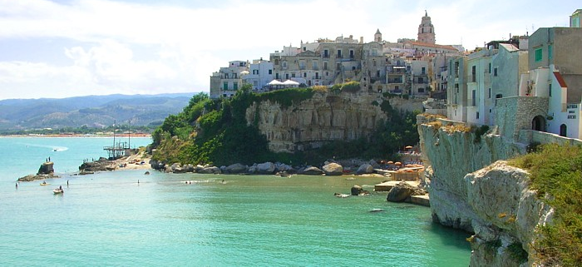

Vieste, on the Gargano Peninsula
Day 12 – Friday, December 5: A full day of sightseeing on the Gargano Peninsula. We first experience the Bosco d’Umbra, a majestic “Black Forest” of beech, maple, chestnut, oak, and other trees generally found in more northern regions, but thriving here because of the altitude, over 1,000 meters above sea level. Then we visit Monte Sant’Angelo, a famous hilltop centre of pilgrimage, as the Archangel Michael reputedly appeared here in a cave around 490AD; like Rome and Santiago de Compostela, this site was the terminus of a famous trans-European pilgrims’ road, the St. Michael’s Way, which started in Cornwall and reached Italy via a string of other famous sanctuaries devoted to the Archangel, such as the Mont St. Michel. And we finish with a scenic drive along the peninsula’s magnificent coast, dotted with fabulous beaches, rocky promontories, and offshore rocks known as faraglioni, to our hotel in Vieste. No group dinner this evening.
Day 13 – Saturday, December 6: This morning we discover the rugged but scenic northern coast of the Gargano Peninsula, featuring the fishing village of Peschici and the picturesque town of Rodi Garganico with its long sandy beach. Return to Vieste and rest of the day at leisure, except for dinner in the restaurant of our hotel.
Day 14 – Sunday, December 7: Early departure and scenic all-day drive towards Rome, a total distance of approximately 400 km. Following the Adriatic coastline, we leave Puglia and enter the small province of Molise, tucked between the Adriatic and the Apennine Mountains. Short stop in the seaside resort and seaport of Termoli, liberated in the fall of 1943 by Canadian troops who called it “Maple Leaf City”! Then we turn inland, enter the Abruzzi region, and cross the rugged Abruzzo National Park, with its forest-covered mountains inhabited by a variety of wildlife, including bears and wolves. Via the town of Sulmona we reach Fiumicino in late afternoon. Time permitting, shortly before our arrival we will take a look at a well-preserved stretch of the ancient Appian Way just outside of Rome, featuring mausoleums and catacombs! Accommodation in the 4-star/first-class Hotel Mercure or similar. Final group dinner in the hotel or in a nearby restaurant.
Day 15 – Monday, December 8: After a leisurely breakfast, transfer to Fiumicino Airport by hotel shuttle and non-stop return flight from Rome to Toronto with Air Canada, departing at 12:15 and arriving at 4:15PM.

Tour Price: $5,995 CAD
Includes return airfare from Toronto to Rome
Land only: $4,595 CAD
Single Supplement: $885

Included in the tour price are:
- Economy class return flight from Toronto to Rome with Air Canada.
- Overland travel by private coach.
- Accommodation in four-star/first-class hotels, based on double occupancy
- Meals: buffet breakfast daily and a total of eight full dinners or lunches.

Not included are:
- All expenses of a personal nature.
- Meals other than those mentioned above.
- Beverages with dinners.
- Coach driver’s gratuity of 30 Euros per person, to be paid locally.
- Travel insurance, available upon request.

YOUR TOUR HOST AND GUIDE: JACQUES R. PAUWELS
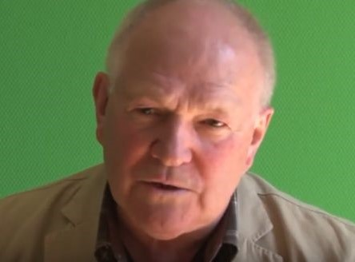
Historian Jacques R. Pauwels is the author of a book on ancient history, including Greek and Roman history, “Beneath the Dust of Time”, published in London in 2009 but with a new and updated edition expected in 2025. His books are available in nine languages, including French, German, Italian, Spanish, and even Turkish.

PAUWELS TRAVEL BUREAU LTD.
Mailing Address: 43 Condor St, Kitchener, ON, N2K 0B2
Tel: 519-753-2695/1-800-380-3974 – Fax: 519753-6376 - Email: tours@pauwelstravel.com

REGISTRATION FORM
Please book _________ seat(s) on the Puglia Tour from November 24 to December 8, 2025.

I wish to book flights_____ OR land only ______.
(If booking land only please send the office a copy of your flight details).

Please be prepared to pay a deposit of $1200 per person and any applicable insurance premium at time of registration. Balance is invoiced no later than 60 days prior to departure.

WE REQUIRE A COPY OF YOUR PASSPORT (INFORMATION PAGES ONLY) VALID 6 MONTHS AFTER THE TOUR TO BE SENT IN WITH YOUR REGISTRATION FORM.

PASSPORT NAME(S):
Surname First Middle(s)

Date of Birth (ddmmmyyyy):

Surname First Middle(s)

Date of Birth (ddmmmyyyy):
Address: City:

Postal Code: Phone: Cell Phone:

Email:
If traveling alone, is a single room required? Yes No
If sharing, what is your bed preference: twin (2 beds) double (1 bed) ?
SPECIAL REQUIREMENTS: Please list any dietary requests, allergies, special physical needs, or frequent flyer numbers etc., below. We cannot ensure requests made 30 days or less prior to departure will be possible.

INSURANCE: Review plans and rates by clicking here or calling the office. Record your quoted premium below:
All-Inclusive: Emergency Medical: Non-Medical/Trip Cancellation:
Decline Insurance:

PAYMENT: Cheque payable to Pauwels Travel Bureau LTD, e-transfer to tours@pauwelstravel.com or call the office to provide credit card (Visa, Mastercard, American Express) to Sandra or Jessica.
Amount To Pay: ______________

CONSENT: “I/we have read and agree to the terms and conditions attached to the tour program, have selected or declined insurance, indicated any special requests, and authorize payment of the deposit and/or any quoted insurance.”

Date_______ Signature____________________________

Date_______ Signature____________________________

PAUWELS TRAVEL BUREAU LTD.
Mailing Address: 43 Condor St, Kitchener, ON, N2K 0B2
Tel: 519-753-2695/1-800-380-3974 – Fax: 519753-6376 - Email: tours@pauwelstravel.com

TERMS & CONDITIONS
RESERVATIONS AND DEPOSITS:
Reservations should be made as early as possible to ensure the departure of your choice. No reservations will be accepted without a deposit and signed registration form. Deposit amounts vary by tour and are listed in the registration form.
REFUND OF UNUSED ARRANGEMENTS:
Because the rates of Pauwels Travel Bureau Ltd. are based on group participation, no refund can be made for any tour accommodation or tour service, or tour feature not taken. If cancellation occurs while the tour is in progress, no refund can be made for the tour portion not taken. We strongly suggest that to allow for any unexpected contingencies, you purchase the all-inclusive insurance.
CANCELLATION POLICY:
Refund of deposit is made if cancellation is received in writing by Pauwels Travel Bureau Ltd. at least 91 days prior of the departure date of the tour less a $250.00 non-refundable administrative fee per person. For cancellation received in writing 90 days prior or less the following cancellation penalties apply for tour costs:
- 90 days to 61 days before departure: 35% of tour cost
- 60 to 31 days before departure: 65% of tour cost
- 30 – 0 days prior to departure: 100% of tour cost

Penalties for cancelling insurance or individual airfare may differ than the policy above. Clients are advised to review the cancellation terms for any additional services they may have purchased for the tour.
RESPONSIBILITY:
The acceptance of the initial service to be provided under the tour shall be considered an acceptance by the tour member of those conditions. We also reserve the right to decline, to accept or retain any person as a member of the tour. We reserve the right without notice, to withdraw any part or all of the tour. Factors such as airline schedule changes, hotel overbookings, inclement weather, travel warnings by the Canadian Government etc. may necessitate changes in the itinerary. There may also be other circumstances in which changes become necessary or advisable. By commencing the tour, I agree to the release and agreement as included below.
RELEASE & AGREEMENT:
By placing my deposit, submitting my registration, and commencing the tour I understand and agree to the following:
1. That all tours are delivered in conjunction with other service providers, including but not limited to travel agent and booking services, airlines, hotel and accommodation providers, transportation providers including but not limited to coach, train and ferry services, restaurant providers, and local guides. We shall not be held responsible for the failure by any person or company to render any transportation, lodging or other travel service to be provided on the tour. All hotels, transportation and other travel services are provided subject to all the terms and conditions under which they are offered to the public generally.
2. I know that tour programs include walking and may including hiking and fitness programs that have potentially hazardous activities associated with them. I should not participate prior to approval by my physician. I assume any and all other risks associated with these events included but not limited to falls, contact with other participants, the effects of the weather including high heat and/or humidity.
3. To release, indemnify and hold harmless Pauwels Travel Bureau and their affiliates (which term shall include parents, subsidiaries, officers, directors, shareholders, agents and employees of Pauwels Travel Bureau as well as Pauwels Travel themselves) (the “Released Parties”) from, and agree not to sue the Released Parties for, any claims that I may have arising from, or in connection with, any personal injury, bodily injury, mental anguish, emotional distress, physical, property or other damage that I may suffer from any cause whatsoever related in any way to my participation in this tour. Without limiting the generality of the foregoing, I release, indemnify, and hold harmless the Released Parties from, and agree not to sue them for any personal injury, bodily injury, mental anguish, emotional distress, physical, property or other damage that I may suffer from the Released Parties’ negligence other than from intentional or reckless acts by such parties. I further agree to release, indemnify and hold harmless the Released Parties from any and all acts of God, war (whether declared or undeclared), terrorist activities, incidents of politically motivated violence, illness or quarantine, strikes or government restrictions or the acts or omissions of any other agents over which the Released Parties have no direct or indirect control, including, without limitation, airlines, railways, bus companies, hotels, shipping companies, guides and sub- contracted agents or tour operators. This release also includes activities not offered that may be considered risky. I further release any Tour Directors, bus drivers or other individuals involved in my tour.
4. That the air carrier’s liability for loss of or damage to baggage or property, or for death or injury to person, is limited by their tariffs, or the Warsaw Convention, or both.
5. That Pauwels Travel Bureau shall have no liability or responsibility for me when I am absent from activities, such as visits to friends or relatives or during pre-tour/post-tour option periods if the pre-tour/post-tour period does not include the services of a Tour Director.
6. To abide by directions of my Tour Director or other leadership personnel during my tour. Failure to do so may result in my termination from tour immediately. I understand that to disobey such rules or directions are to waive the right to any refund, and that I may be sent home at my own expense. The participant and family undertake full financial responsibility for any damage caused by the participant and agree to pay his/her return home on the first available flight, should his/her behaviour be deemed detrimental to the welfare of the group.
7. To abide by all local laws when in Canada and abroad, including those concerning drugs and alcohol. (Minors must have parents’ permission to use alcohol even if the local law would otherwise permit them to.) I understand that if I abuse or disobey such laws, even unintentionally, I waive my right to a refund, and Pauwels Travel may send me home at my own expense. I also understand that, should local authorities be involved, I will be subject to the laws of the country I am visiting.
8. That if I become ill or incapacitated, Pauwels Travel and its employees, or a designated chaperone may take any action they deem necessary for my safety and well-being, including securing medical treatment (at my own expense) and transporting me home. In the event of a medical emergency, Pauwels Travel will attempt to cause appropriate treatment to be administered, and the traveller authorizes Pauwels Travel to do so. Pauwels Travel, however, makes no warranty that it will be able to cause effective (or any) emergency treatment to be administered.
9. That Pauwels Travel may use any film likenesses taken of me and any of my comments while on a tour for future publication and use my contact information for future Pauwels Travel communications.
A WORD ABOUT GROUP AIRFARES:
Please note that when booking one of our air inclusive tours, Pauwels Travel has negotiated reduced rates with the airline that we are able to confirm and lock in up to 359 days before travel. While it is wonderful to share the savings and flexibility this provides with you, our valued guests, the privilege does come with some restrictions. In some cases, it may not be possible to collect frequent flyer miles, you may not be able to check in online 24 hours before travel, or you may need to try checking in with your ticket number rather than your booking reference. Additionally, most airlines do not allow advanced seat-selection on group airfares. It is the airline’s policy, not ours, that prevents us from assigning specific seats. If a request is made, it is passed on to the airline by our staff when they submit the names to the airline 60 days prior to departure but no requests are guaranteed. Our staff will not be able to aid in advanced seat selection if the airline does not allow it on the group airfare. If a certain type of seat is indispensable to you, we suggest that you book our tour on a “land only” basis and make individual flight arrangements, in which case you may be able to get the seat of your choice; Pauwels Travel would be happy to assist you with that reservation. We will offer you the best fare available, but please note that this can only be done once a tour is a guaranteed departure because individual airfare conditions are stricter than the conditions of the group airfare rate. We thank you in advance for your kind understanding of the above!

